

MATH EXPRESSIONS

Assignment # 5

JAVASCRIPT

1. Write a program that take two numbers & add them in a new variable. Show the result in your browser.

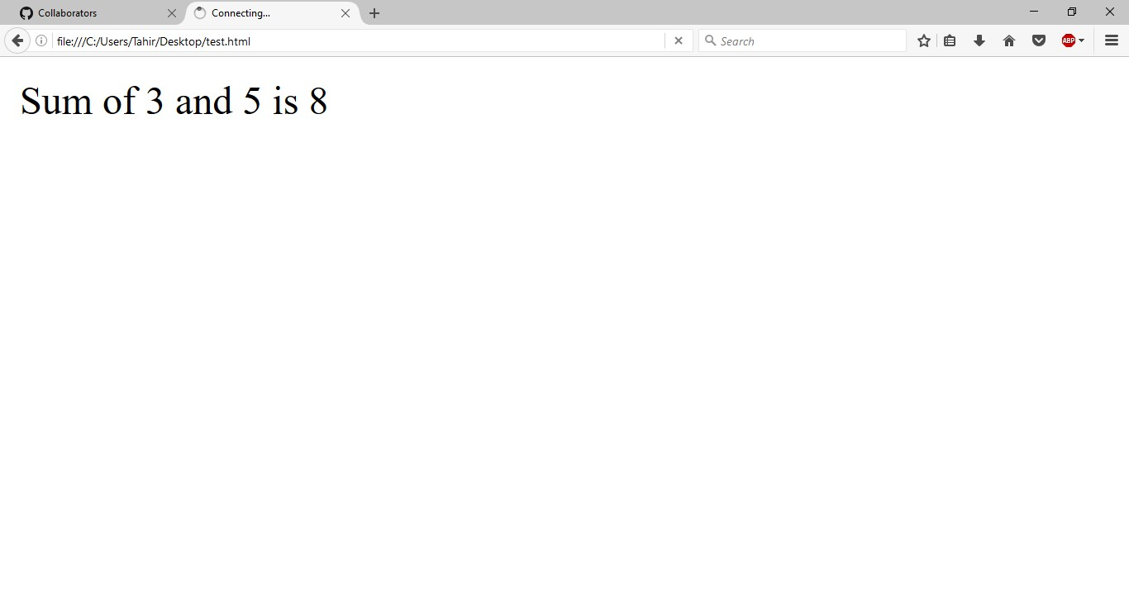

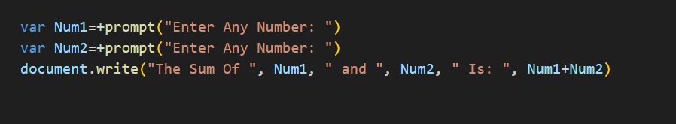

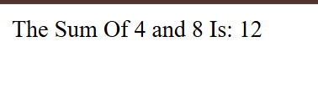

1. Repeat task1 for subtraction, multiplication, division & modulus. 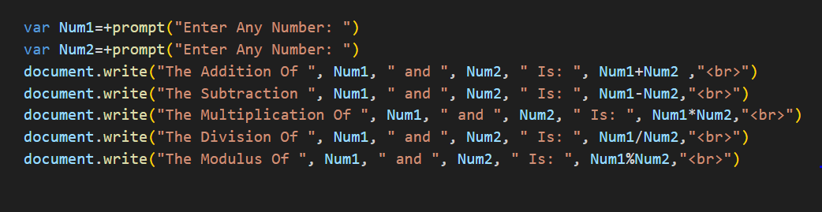

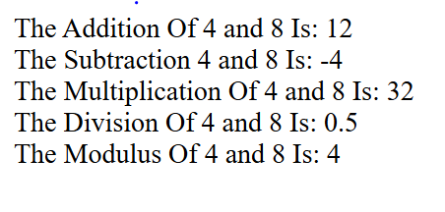

1. Do the following using JS Mathematic Expressions
   1. Declare a variable.
   2. Show the value of variable in your browser like “Value after variable declaration is: ??”.
   3. Initialize the variable with some number.
   4. Show the value of variable in your browser like “Initial value: 5”.
   5. Increment the variable.
   6. Show the value of variable in your browser like “Value after increment is: 6”.
   7. Add 7 to the variable.
   8. Show the value of variable in your browser like “Value

after addition is: 13”.

* 1. Decrement the variable.
  2. Show the value of variable in your browser like “Value after decrement is: 12”.
  3. Show the remainder after dividing the variable’s value by 3.
  4. Output : “The remainder is : 0”.

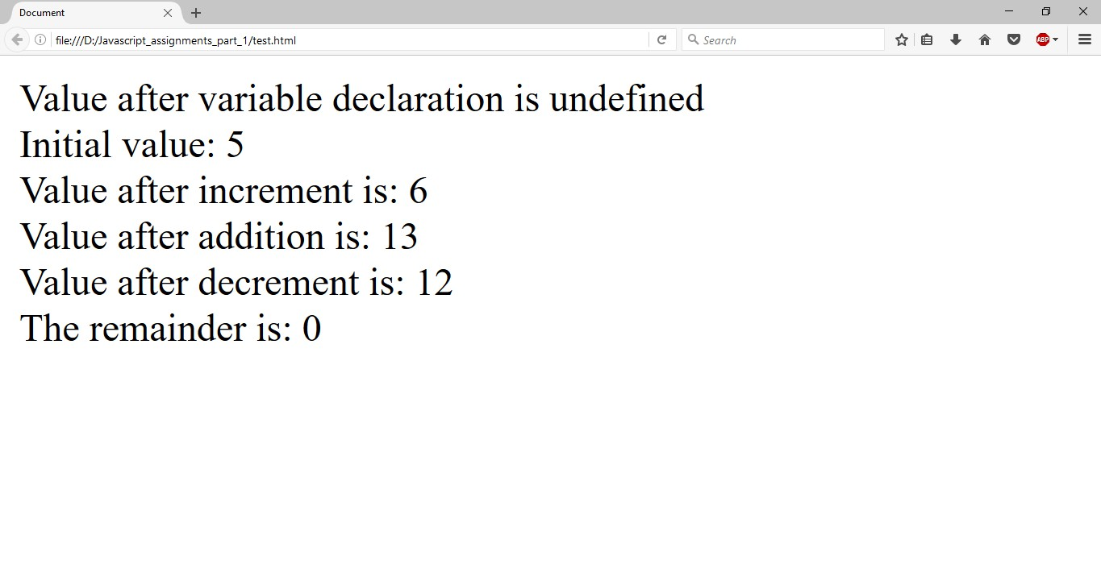

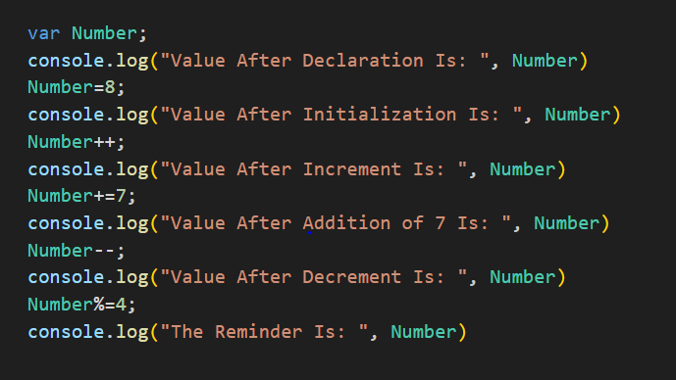

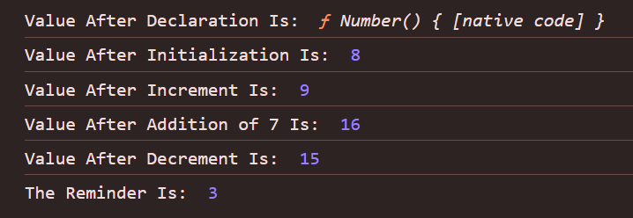

1. Cost of one movie ticket is 600 PKR. Write a script to store

ticket price in a variable & calculate the cost of buying 5 tickets

to a movie. Example output:

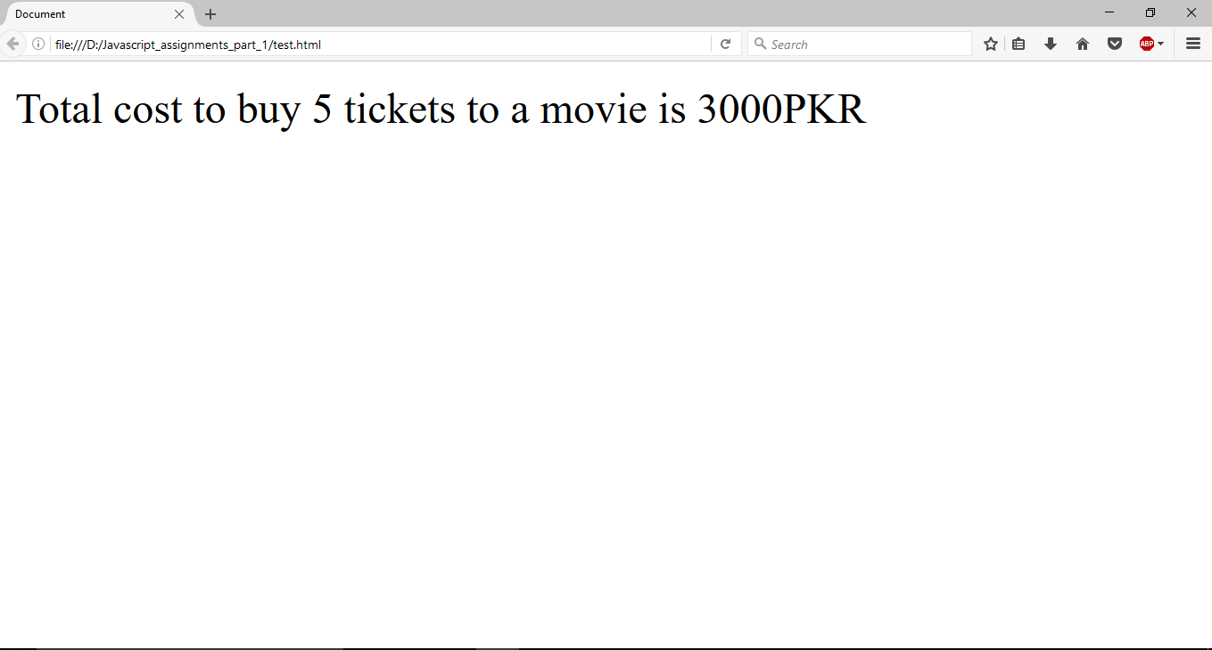

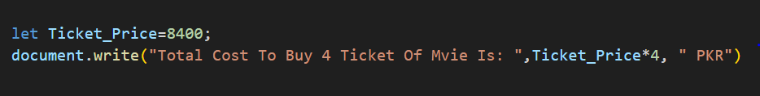

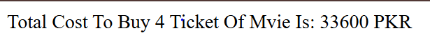

1. Write a script to display multiplication table of any number in your browser. E.g

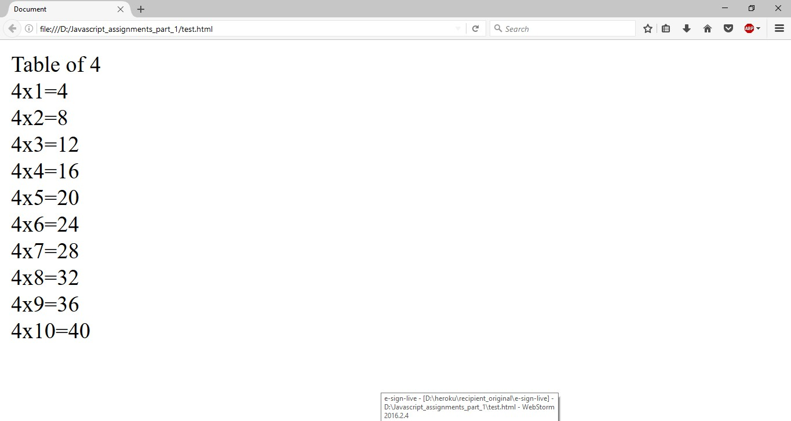

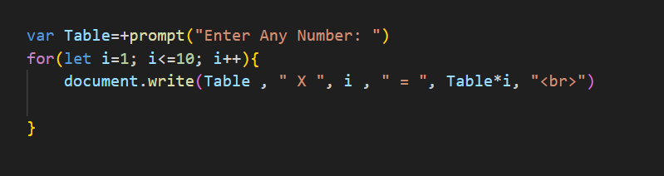

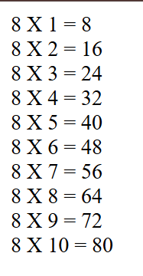

1. **The Temperature Converter:** It’s hot out! Let’s make a converter based on the steps here.
   1. Store a Celsius temperature into a variable.
   2. Convert it to Fahrenheit & output “NNoC is NNoF”.
   3. Now store a Fahrenheit temperature into a variable.
   4. Convert it to Celsius & output “NNoF is NNoC”. Conversion Formulae:

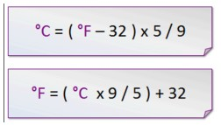

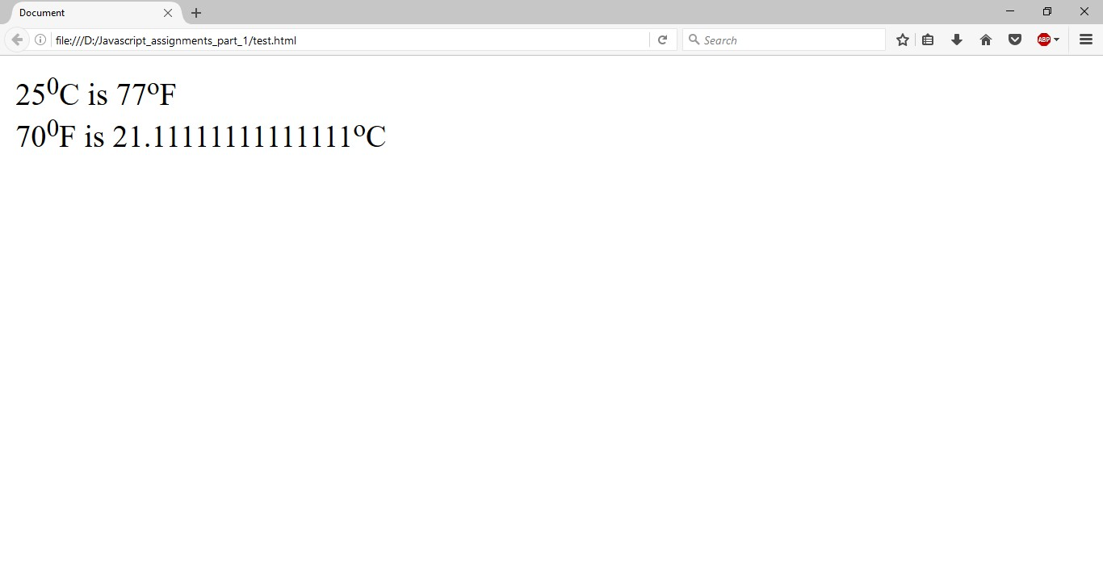

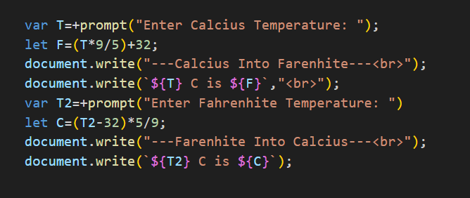

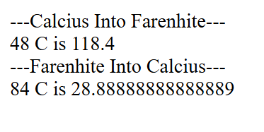

1. Write a program to implement checkout process of a shopping cart system for an e-commerce website. Store the following in variables
   1. Price of item 1
   2. Price of item 2
   3. Ordered quantity of item 1
   4. Ordered Quantity of item 2
   5. Shipping charges

Compute the total cost & show the receipt in your browser.

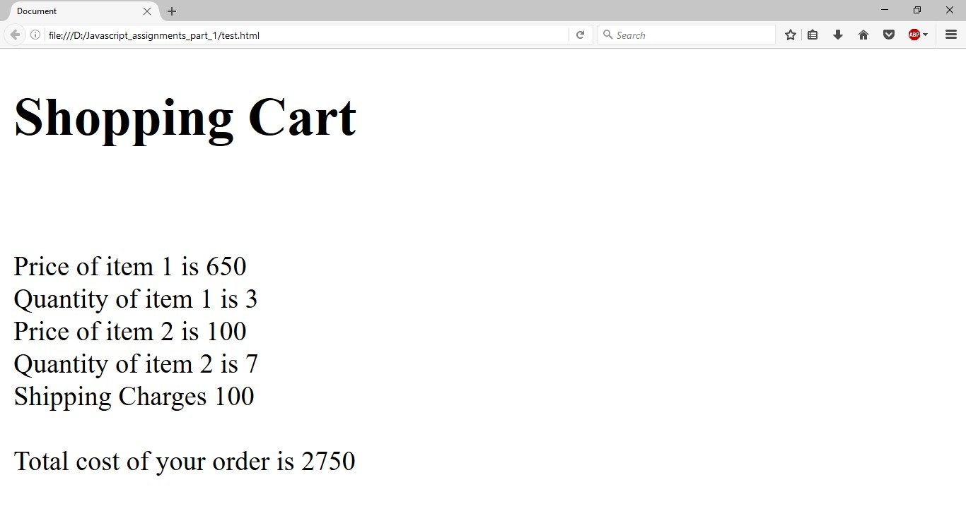

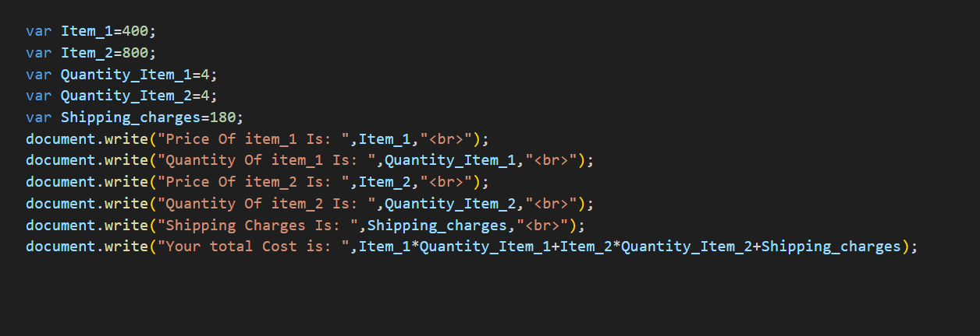

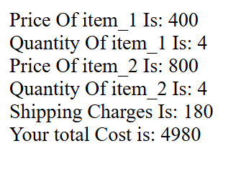

1. Store total marks & marks obtained by a student in 2 variables. Compute the percentage & show the result in your browser

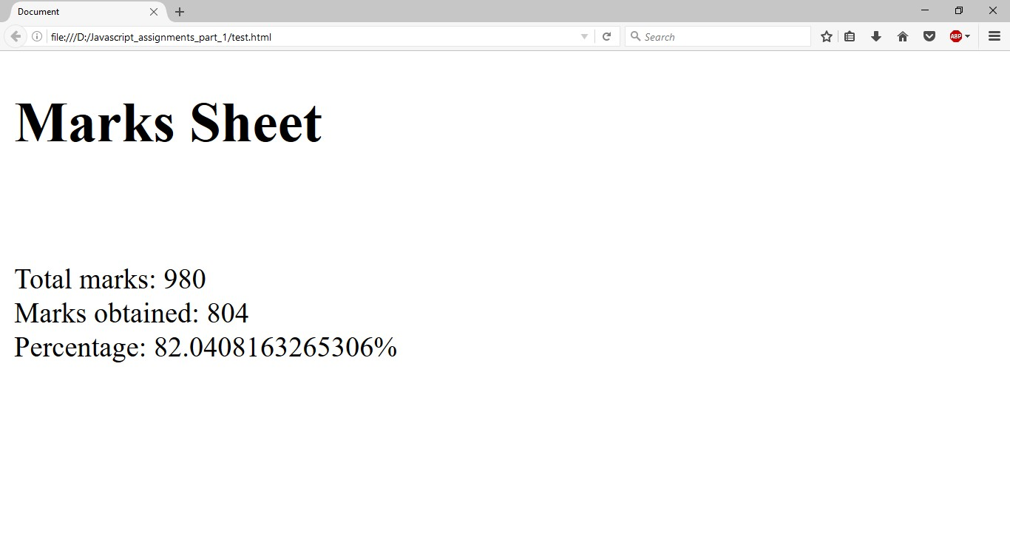

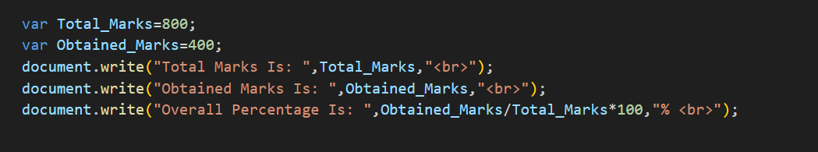

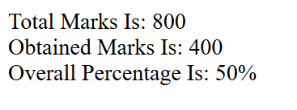

1. 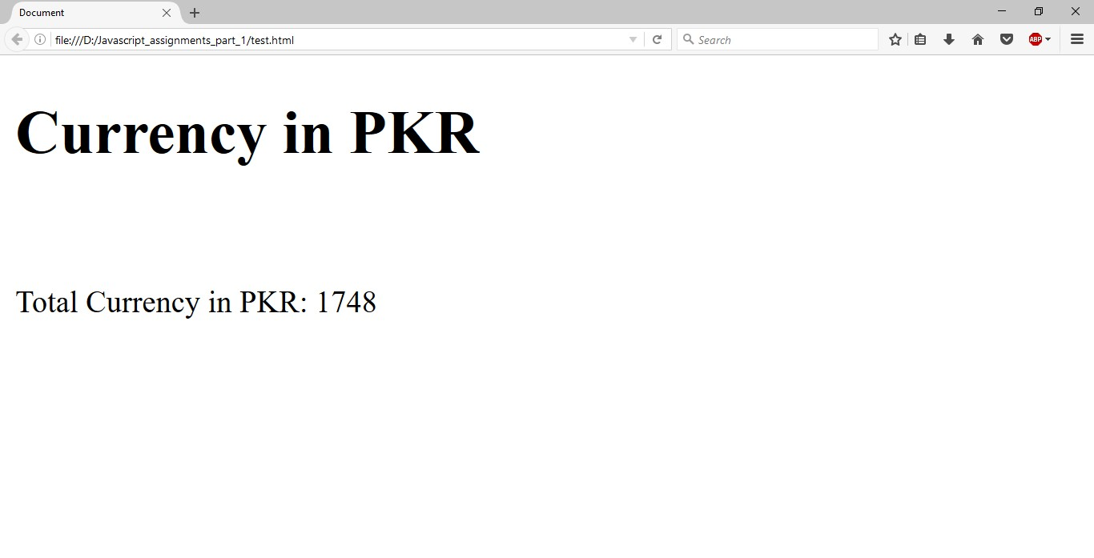Assume we have 10 US dollars & 25 Saudi Riyals. Write a script to convert the total currency to Pakistani Rupees. Perform all calculations in a single expression. (Exchange rates : **1 US Dollar = 104.80 Pakistani Rupee** and **1 Saudi Riyal = 28 Pakistani Rupee**)

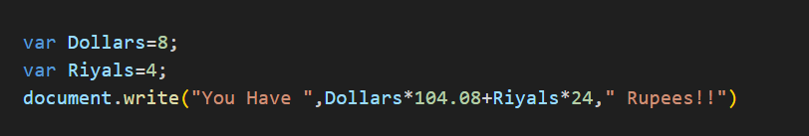



1. Write a program to initialize a variable with some number and do arithmetic in following sequence:
   1. Add 5
   2. Multiply by 10
   3. Divide the result by 2

Perform all calculations in a single expression

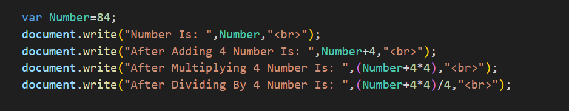

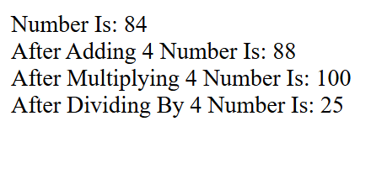

1. **The Age Calculator:** Forgot how old someone is? Calculate it!
   1. Store the current year in a variable.
   2. Store their birth year in a variable.
   3. Calculate their 2 possible ages based on the stored values.

Output them to the screen like so: “They are either NN or NN years old”.

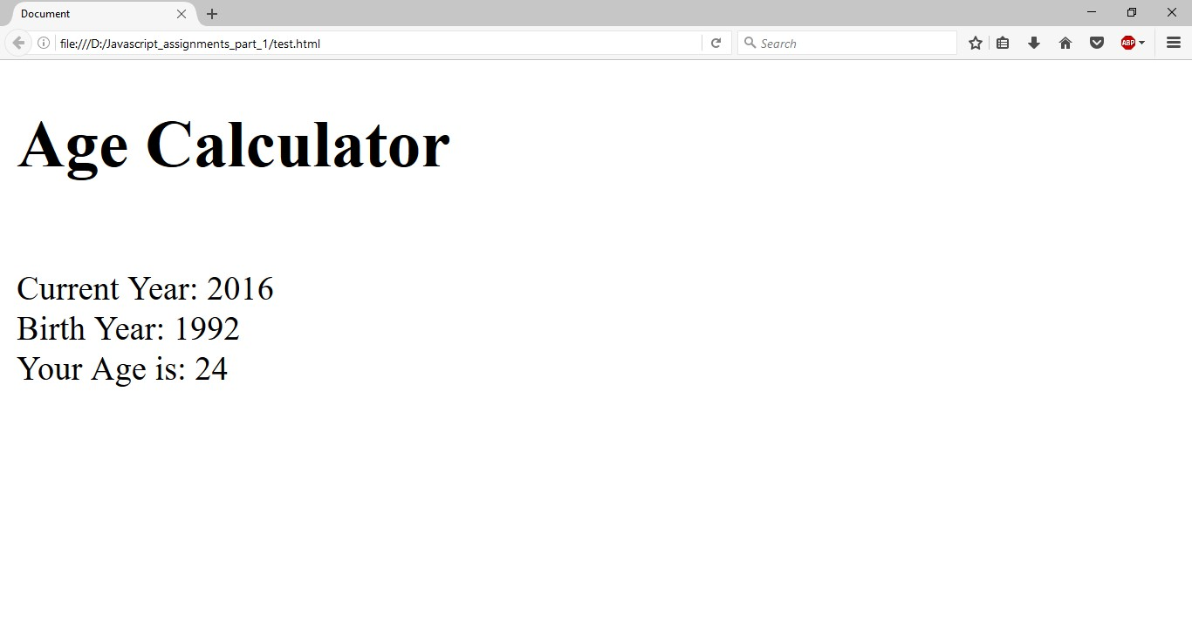

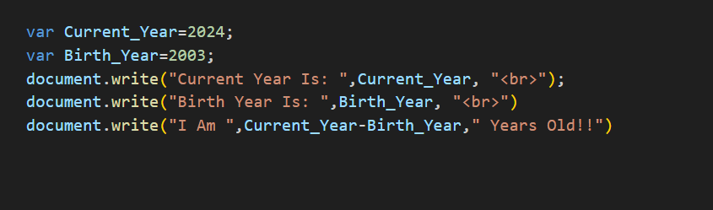

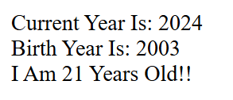

1. **The Geometrizer:** Calculate properties of a circle.
   1. Store a radius into a variable.
   2. Calculate the circumference based on the radius, and output “The circumference is NN”.

*(Hint : Circumference of a circle = 2 π r , π = 3.142)*

Calculate the area based on the radius, and output “The area is NN”. *(Hint : Area of a circle = π r2, π = 3.142)*

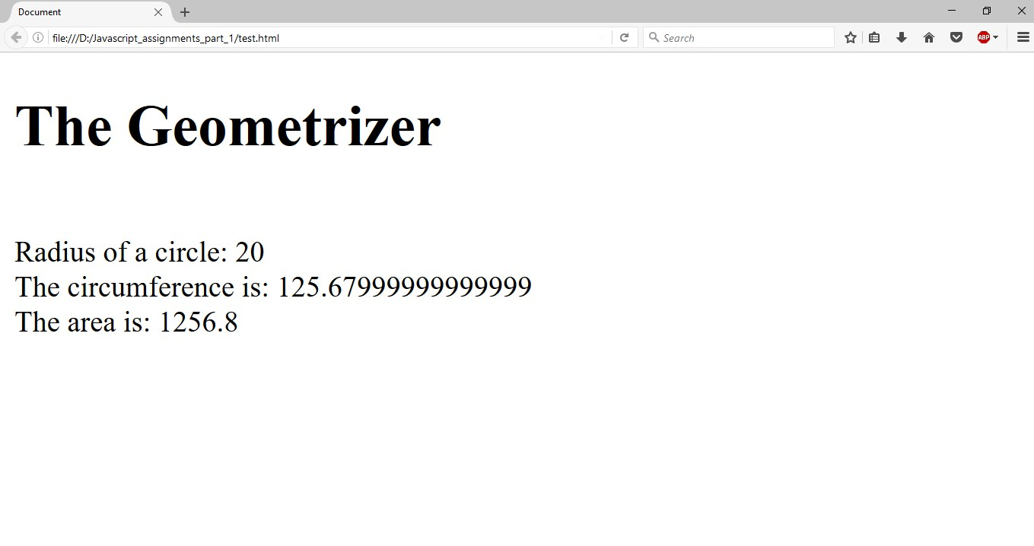

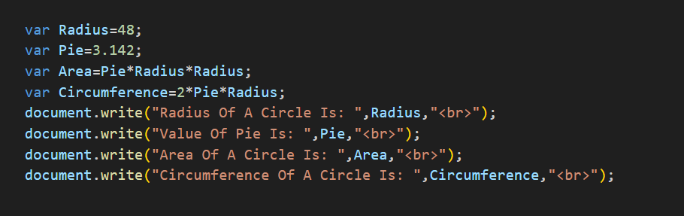

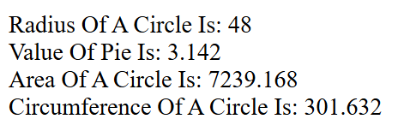

1. **The Lifetime Supply Calculator:** Ever wonder how much a “lifetime supply” of your favorite snack is? Wonder no more.
   1. Store your favorite snack into a variable
   2. Store your current age into a variable.
   3. Store a maximum age into a variable.
   4. Store an estimated amount per day (as a number).
   5. Calculate how many would you eat total for the rest of your life.

Output the result to the screen like so: “You will need NNNN to last you until the ripe old age of NN”.

